1. Write a C program to compute the perimeter and area of a rectangle with a height of 20cm and width of 1m

#include<stdio.h>

void main()

{

int h = 20, w = 100, a, p; // 1m=100cm

printf("All Dimensions are in cm\n");

a = h*w;

p = 2*(h+w);

printf("Area = %dcm^2\nPerimeter = %dcm",a,p);

}

Output:

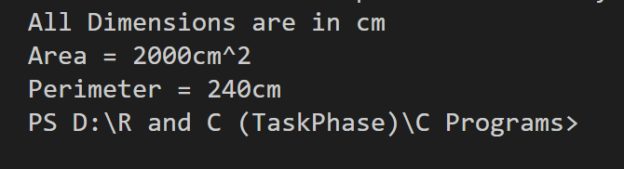

2.Write a C program to find the third angle of a triangle if two angles are given

#include<stdio.h>

void main()

{

    int a,b,c;

   printf("enter two angles in degrees\n");

   scanf("%d%d",&a,&b);

   c = 180-(a+b);

   printf("%d is the third angle",c);

}

Output:

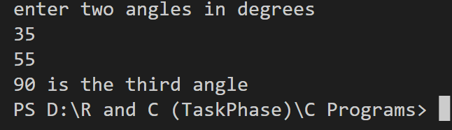

3. Write a C program to convert specified days into years, weeks and days. Note: Ignore leap year

#include<stdio.h>

void main ()

{

int n,y,w,d,r;

printf("Enter the number of days\n");

scanf("%d",&n);

y = n / 365;

w = (n%365)/7;

r = (n%365)-(w*7);

d = r%7;

printf("%d years %d weeks %d days ",y,w,d);

}

Output:

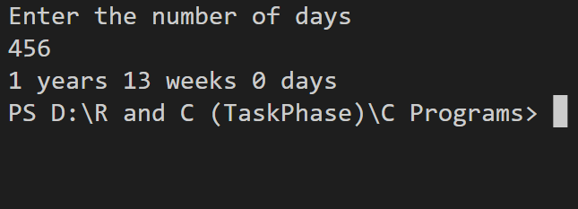

4. Reverse a given string/character array

#include<stdio.h>

void main()

{

char str[80],temp[80];

int i,n=0;

printf("enter your string\n");

gets(str);

for(i=0;str[i]!='\0';i++)

{

n++;

}

for(i=0;i<n/2;i++)

{

temp[i] = str[i];

str[i] = str[n-1-i];

str[n-1-i] = temp[i];

}

puts(str);

}

Output:

5. Write a C program to check if a triple is present in an array of integers or not. If a value appears three times in a row in an array it is called a triple

#include<stdio.h>

void main ()

{

int i,n,a[10],e;

printf("enter number of elements in the array\n");

scanf("%d",&e);

printf("enter your array\n");

for(i=0;i<e;i++)

{

scanf("%d",&a[i]);

}

printf("Enter your number\n");

scanf("%d",&n);

for(i=0;i<e;i++)

{

if(n==a[i])

{

if(n==a[i+1])

{

if(n==a[i+2])

{

printf("%d is a triple\t",n);

}

else

{

continue;

}

}

else

{

continue;

}

}

else

{

continue;

}

}

}

Output:

6.Write a C program to convert a string with numeric characters to an integer

#include<stdio.h>

#include<stdlib.h>

void main()

{

char str[80];

int a;

printf("Enter your string with numerical characters\n");

gets(str);

a = atoi(str);

printf("%d",a);

}

Output:

7. Write a C program to accept a coordinate point in a XY coordinate system and determine in which quadrant the coordinate point lies

#include<stdio.h>

void main ()

{

int x,y;

printf("Enter your x and y coordinate respectively\n");

scanf("%d %d",&x,&y);

if(x>=0&&y>=0)

{

printf("First Quadrant");

}

if(x<0&&y>=0)

{

printf("Second Quadrant");

}

if(x<0&&y<0)

{

printf("Third Quadrant");

}

if(x>=0&&y<0)

{

printf("Fourth Quadrant");

}

}

Output:

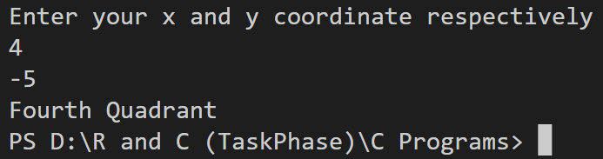

8. Find the largest among 3 numbers using conditional operator(?:)

#include<stdio.h>

void main ()

{

int a,b,c,lar;

printf("enter your three numbers\n");

scanf("%d %d %d",&a,&b,&c);

lar = (a>b)?((a>c)?a:c):((b>c)?b:c);

printf("%d is the largest",lar);

}

Output:

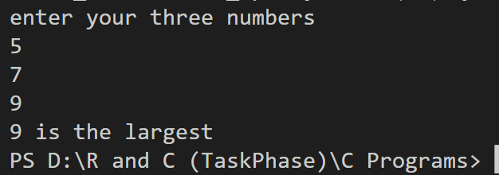

9.Write a program in C to display the multiplication table vertically from 1 to n

#include<stdio.h>

void main()

{

int i,j;

printf("Enter the value of n\n");

scanf("%d",&i);

for(j=1;j<=10;j++)

{

printf("%dx%d = %d\n",i,j,i*j);

}

}

Output:

10. Write a program in C to print the Floyd's Triangle with n rows. If n=5 then the following is the output:

1

01

101

0101

10101

#include<stdio.h>

void main()

{

int i,j,n,k;

printf("Enter the number of rows\n");

scanf("%d",&n);

for(i=1;i<=n;i++)

{

for(j=0;j<i;j++)

{

k=i+j;

if(k%2==0)

{

printf("0 ");

}

else

{

printf("1 ");

}

}

printf("\n");

}

}

Output:

11. Write a program in C to separate odd and even integers in separate arrays

#include<stdio.h>

void main()

{

int arr[50],even[50],odd[50],n,i,c1=0,c2=0;

printf("enter the number of integers in the array\n");

scanf("%d",&n);

printf("enter your integers\n");

for(i=0;i<n;i++)

{

scanf("%d",&arr[i]);

}

for(i=0;i<n;i++)

{

if(arr[i]%2==0)

{

even[c1]=arr[i];

c1++;

}

else

{

odd[c2]=arr[i];

c2++;

}

}

printf("Even \n ");

for(i=0;i<c1;i++)

{

printf("%d ",even[i]);

}

printf("\nOdd \n");

for(i=0;i<c2;i++)

{

printf("%d ",odd[i]);

}

}

Output:

12. Write a program in C to find the maximum number between two numbers using a pointer

#include<stdio.h>

void main ()

{

    int a,b,*pA,*pB;

    printf("enter your two numbers\n");

    scanf("%d%d",&a,&b);

    pA = &a;

    pB = &b;

    if(*pA>*pB)

    {

       printf("largest %d",*pA);

    }

    else

    {

        printf("largest %d",*pB);

    }

}

Output:

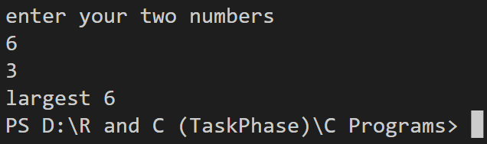

13. Write a C programming to repeatedly add all digits of a given non-negative number until the result has only one digit.

Example:

Input: 47

Output: 2

Explanation: The formula is like: 4 + 7 = 11, 1 + 1 = 2

#include<stdio.h>

int sum=0,num,d;

void sum_digits(int num)

{

    while(num!=0)

    {

        d = num%10;

        num = num/10;

        sum = sum + d;

    }

    if(sum/10==0)

    {

        printf("%d",sum);

    }

    else

    {

        num = sum;

        sum = 0;

        sum_digits(num);

    }

}

void main ()

{

    printf("Enter your number\n");

    scanf("%d",&num);

    sum_digits(num);

    }

Output:

14. The prime factors of 13195 are 5, 7, 13, 29. Write a C program to find the largest prime factor of the number n taken as input from the user.

#include<stdio.h>

void main()

{

int n,i,j,flag=0,l=0,arr[80],lar;

printf("Enter the number\n");

scanf("%d",&n);

for(i=2;i<=n/2;i++)

{

if(n%i==0)

{

for(j=2;j<=i/2;j++)

{

if(i%j!=0)

{

continue;

}

else

{

flag = 1;

}

}

if(flag==0)

{

arr[l] = i;

l++;

}

flag=0;

}

}

lar = arr[0];

for(i=1;i<l;i++)

{

if(arr[i]>lar)

{

lar = arr[i];

}

}

printf("the largest prime factor of %d is %d",n,lar);

}

Output:

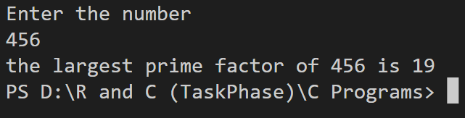

15. Write a C program to divide two given integers without using multiplication, division and mod operator. Return the quotient after dividing

#include<stdio.h>

void main()

{

int a,b,q=0;

printf("enter your dividend and divisor respectively\n");

scanf("%d%d",&a,&b);

while(a>=b)

{

a = a - b;

q++;

}

printf("quotient is %d",q);

}

Output:

